http://paranormalmontana.blogspot.com/2009/03/deer-lodge-and-red-gate.html [1]

Deer Lodge and the Red Gate
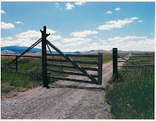

Like I said in the post just previous, I was surfing around, seeing what I could find, and I came up with the Deer Lodge "Red Gate" story. I had never heard of this before, even though Deer Lodge is pretty close to Helena.
It seems there is a lady by the name of Linda Croonquist/Cowen who was originally from Deer Lodge, graduated in 1963, attended MSU for nursing, and moved away to Texas. Later, after painful surgery she started having memory flashes of strange childhood events and she got interested in remote viewing (kind of a psychic way of seeing things distant in space-time, like clairvoyance in a way). And she found out from family that they had some weird alien and UFO experiences in the Deer Lodge valley; there are lots of stories apparently. She got some money and talent together, came back to Deer Lodge, and made a documentary about it, called "The Secret of Redgate".
Here's a rundown of the Red Gate story, gathered from the two websites.
Cowen said, "My brother consciously remembers having a lot of encounters with aliens as a child — playing with them as a child...We didn't know anything about them growing up." Her brother Steve "not only confirmed the contact but was actually shocked that Linda didn’t fully remember the incident. 'You were there,' he said. 'You talked with our little grey friends. I don’t understand why you didn't remember this.' " At the time, Steve was 7 and Linda was 5. As adults, they went through hypnosis to recover associated memories. "Linda vividly described multiple trips aboard UFOs and her interaction with a variety of alien beings, including a kind and compassionate one that looked like a praying mantis. As there were no preying mantis’s in Montana, Linda named this entity the “Grasshopper Lady”. Steve described his visit to another world, one filled with canals under a dim sun."
Most events seem to have occurred in the 1960s, although Cowen said, "We went back to Deer Lodge for two weeks and found out there were a lot of people with this experience, all the way from young high-school kids to people in their 80s." Over the last twenty years, she said there had been hundreds of UFO sightings within a 150 mile radius of Deer Lodge.
Some of the stories include:
-"Crop circle" type marks at Sunnyside near Anaconda, associated with UFO sightings by retired banker Louie Menicucci, as well as horse mutilations similar to more familiar cattle mutilations
-Strange lights, sounds, and power outages
-"Gene G. Hughes, owner of D L Auto Supply in Deer Lodge, told how his aunt and uncle in the 1970s watched a huge brightly-lit football-shaped object land in a meadow near their mountain home. Hughes’ wife Elaine related how a giant UFO landed in the road just ahead of a friend."
-"Cass Casquilho told of standing in the mountains and watching what appeared to be a comet stop still in the night sky more than twice before continuing on its way. The curious sight was witnessed by fellow hunters in the 1970s."
-"Verda Clawson and her friend Helen Schaffer told of a snowmobiling outing in the 1980s which ended when an eerie “beeping” sound chased the group off a mountain in the Redgate area. A large dog with them became frightened and cowed. The two longtime Deer Lodge residents related the same details in separate interviews."
-"Josh Garrison and Brandon Kent, both in their early 20s, said they saw a bright light moving in a field in the Redgate area. Thinking it was a “swather,” a farm harvester, with bright headlights, the young men approached to see if it was one of their friends. But as they approached, the light suddenly sped off and disappeared. This incident occurred in the summer of 2003."
-"Mark Denton, who knew Linda in high school, recalled chasing a solitary bright light through the mountains on more than one occasion back in the 1960s. “It would appear to be right in front of us,” he said. “But just as you topped one hill, it would be over the next. We never did catch the thing.”"
The UFOs apparently also pursued cars in at least two instances, detailed on the Redgate site:
"Bill Kelley, another of Linda’s high school classmates, had quite the opposite experience. He told of one night in 1962 when he, his brother and another friend were driving home late after a dance in Deer Lodge.
“We were all pretty tired,” Kelley recalled. “Usually there was never anyone on the roads that late at night. But all of a sudden I looked in the rearview mirror and there’s a single bright light. I thought to myself, ‘Hmmm, that’s interesting. I wonder who the hell is following us’ or something like that.
“This thing just kept getting brighter and brighter and pretty soon the inside of our car was bright. My brother looked at Kenny and just jumps into the back seat. Then Kenny followed him into the back seat. Well, I’m driving, so I can’t jump in the back seat. It was bright all around us. But as fast as it got bright, it just went away again and my brother says, ‘Aw, it’s just the moon.’ But we looked up and there’s the moon and I thought, ‘There’s not two moons that I know of.’”
Linda was not satisfied with Bill’s story. She felt there must have been more to it, so she asked Bill to undergo hypnosis. Bill agreed and more details of his late night encounter were revealed.
While in a hypnotic state, Bill relived the incident with all its fear and intensity.
“I’m not afraid…I’m not afraid,” he kept mumbling to himself while describing how his brother Jack and Kenny were yelling, “Go, Bill, go! We gotta get out of here! It’s getting closer!” Bill pushed the 1960 Pontiac sedan as fast as it would go on the twisting dark gravel road but the light kept coming.
Despite the pleas of his passengers, Bill stopped the car. “I gotta see…” he muttered stepping from the vehicle.
Awash in a brilliant light shining down on him, Bill stared upward and murmured in awe, “My God, look at the size of that thing…it’s unbelievable.”
But here his narration became confused and disjointed. He squirmed in the comfortable padded chair directly in front of the hypnotist. “I’m a little bit afraid,” he acknowledged in a small quiet voice. “This is not good. This is not good.”
There was also an extensive account of a 1962 encounter by Dick Slater:
“A friend and I double dated and we were in a place called Quake Lake, which was the result of an earthquake off of Yellowstone Park where a number of miners were buried some years ago. This was at night. We were parked on top of the slide area where there were still about 27 bodies that they never did recover. The radio was on. It was a warm evening, in late June if I remember and all of a sudden the radio went off, the music went off. I didn’t pay much attention to it. But the friend that was with me was a pretty good mechanic, so we got out, popped the hood and took a look. Nothing looked out of order. We didn’t know if maybe the battery had gone dead or whatever, so we got back in the car and tried to decide what to do since it was in such a remote area. Then all of a sudden the radio came back on. So we started the car, the lights turned on and everything. We didn’t think too much about it and turned the engine back off.
“Within a period of about 10 minutes, the radio went off again. As soon as the radio went off, the thing I most remember about this, the thing that made it so unique to me, was the stillness, the absence of noise, the vacuum, around us. I noticed the pine needles in the nearby trees were moving yet there was no breeze. There was nothing. It was just completely still. We all sat observing this and were actually scared. We just sat there. It lasted for probably, as best I can remember, a couple or three minutes, maybe a little longer. Then the radio came back on and we started the car and left.”
Shaken by the bizarre incident, Slater vowed never to visit the area again. But just about two weeks later, he was driving within a few miles of the place and remembered the incident.
“It was two in the morning and I was whipping right along and my memory went back to the incident and I thought, ‘Man, this would be a terrible place for your car to quit.’ I was going quite fast because I was anxious about this for whatever reason and wanted to get by there. Then right at the junction to Quake Lake the car quit. The radio went off, the lights went off and I coasted about half a mile, then the lights came back on and I started the car and went on. I had power brakes and power steering on this old ’58 Pontiac and it was tough to steer. I never tried to stop. I wasn’t interested in stopping the car. In fact, I would have liked to have gone as far away from that place as I could.” (http://www.secretsofredgate.com/redgatestory.htm)
Red Gate is a location east of Deer Lodge. "Beginning in the 1950s and continuing right up to today, the area in the mountains east of Deer Lodge was a favorite teenage parking spot. It came to be known as the Redgate area because of an old wooden gate which bisected one of the only roads into the area. The gate at one time had been painted bright red but by the 1950s, only a few reddish streaks remained. Today the gate still stands but there is no sign of the original red paint."
One explanation offered into the 1980s involved a supposed murder of an entire family by a local man who smeared their blood on the gate, but after research of the old police records by law enforcement officers, it was proven to be an urban myth...or should that be a rural myth?
Much of the film and evidence on the Red Gate website is associated with digging into the mystery through remote viewing:
"Remote Viewing (RV), refers to the attempt to gather information about a distant or unseen target using extra-sensory perception. Typically a remote viewer is expected to give information about an object that is hidden from physical view and separated at some distance. All project Redgate viewers had no information regarding targets prior to their sessions, ex ‘blind’." [1]

In addition (Note: Inserted below are actual session sketches from remote viewers and part of the book ‘Ambassadors to the Stars’ (Sivalelli, Tony 2011 [rev 2015] Chapter 5.) [2]

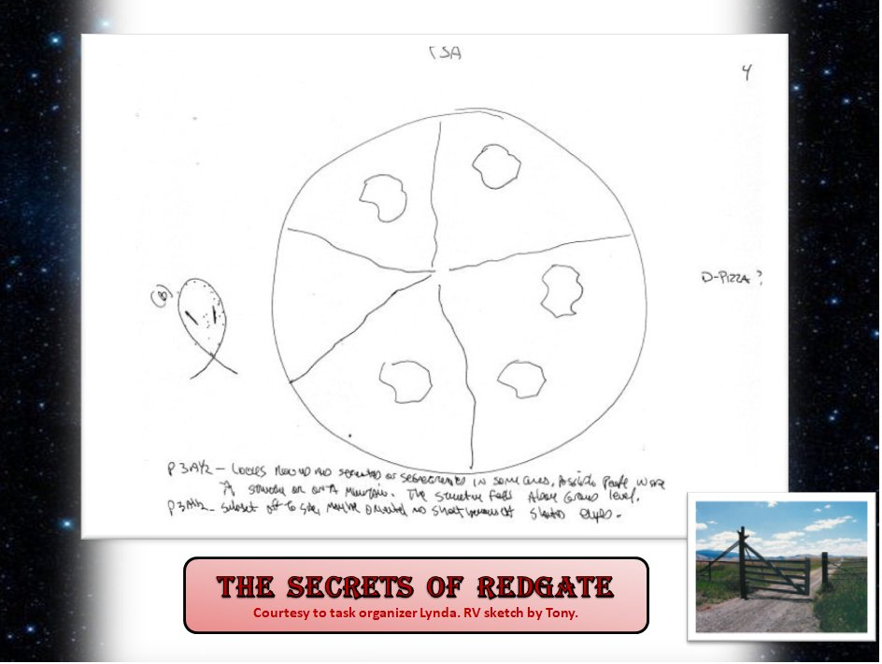
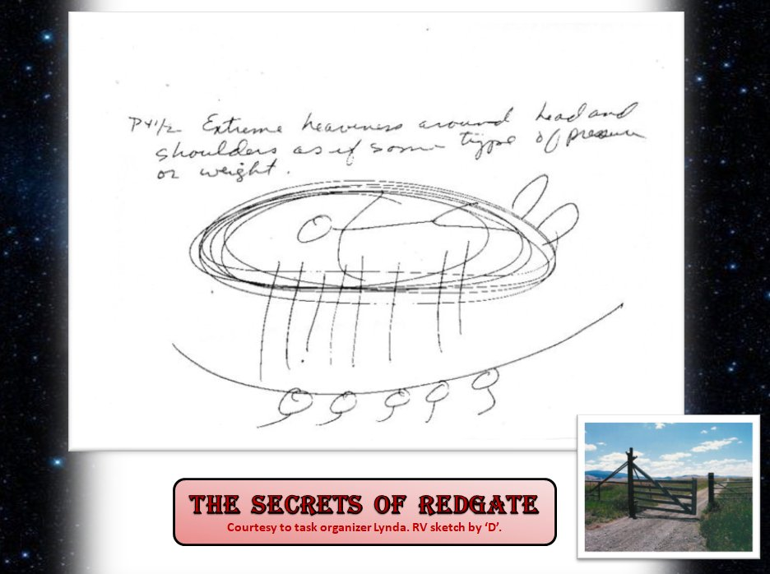
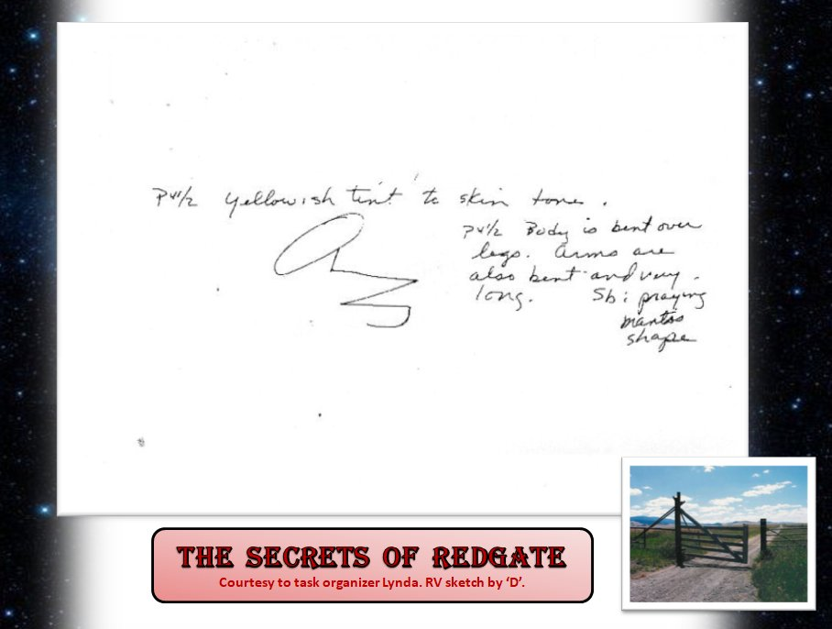
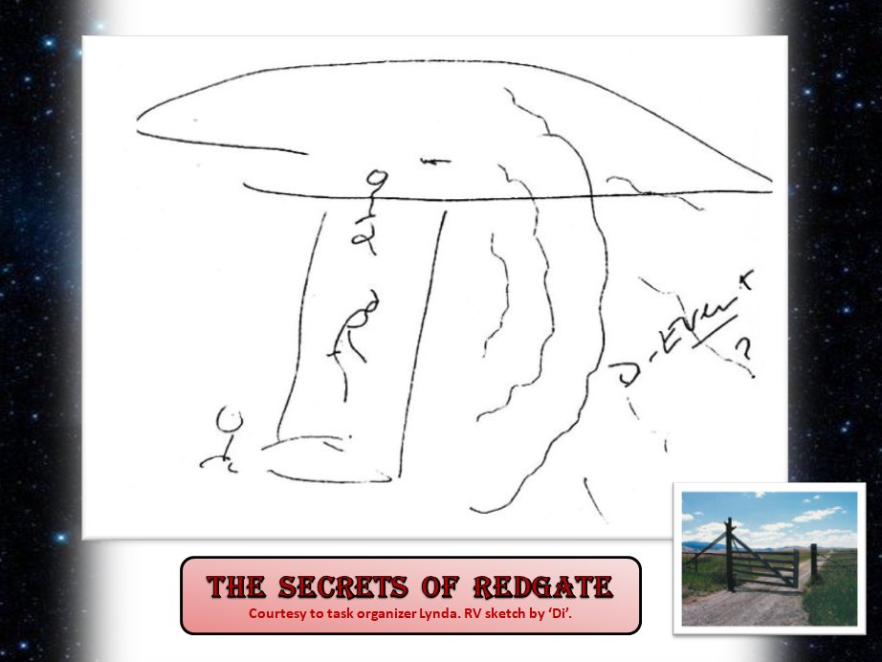
Article continued [1]:
At least one Deer Lodge resident, speaking out on the Red Gate forum, has issues with the situation.
"As I said, I do not deny the existence of aliens and whatnot, I just haven't seen any clues or heard anything up until this last week or so that promotes the idea of their possible visits here. I know every urban legend, and every other paranormal story derived from Deer Lodge's past. Hell, when I was younger my friends and I even had a group called PIT (paranormal investigating team). We investigated every place where these stories originated from, but not once had we heard of extraterrestrial visitations. You have no idea how much we were into this, we know for a fact that "ghosts" exist, but not once had we heard of aliens. ...I just find it incredibly doubtful that anything like that has happened here. ...Oooh, also, the last thing Deer Lodge needs is to be labeled as an "alien" town. We've got enough crazy shit going on here as it is. I get pissed off at the unwanted attention."

But another poster who once lived in Deer Lodge who was not part of the Cowen movie had this to say::
"I am a former resident of Deer Lodge, watched as the wardens struggled though good seasons and ba. drank at the Montana and the corner. and I witnessed firsthand the weirdness of red gate. the first time was so bizarre and scary that all I want to say is that there as something that is more than extraterrestrial that is right out of the twilight zone. and that was only the first time. my first encounter with red gate was really twisted, as some friends and I pulled up to the gate we all noticed that there was a note attached. as I was riding shotgun it was naturally my job to check it out. I walked over and took the note as I stood there in the blistering cold of a clear December night, what I read and saw was beyond anything that can be explained by reasonable people anywhere. the note was addressed to me, on paper that was old brown from years of aging and brittle as a dried leaf, all I ever want to say is that it was from my best friend who had been out of state for some time and that it was a warning to stay away from there.
As we drove on we came to a cattle guard and turned around there. we all then noticed two people walking across a field to an old rotting house, what was strangest, besides the fact that they were walking in the middle of nowhere in below zero temperatures on December 4th 1994, was their color. I didn't notice at first but after the people with me began to panic and scream, yelling to get in the car and carrying on I was told by this kid that they weren’t human beings i was looking at. I looked again and it dawned on me that they were the weirdest things I had ever seen, they were glowing in a strange blue light that was like the color of the moon but it was coming from within them , and so like the dumbass that I was back then I yelled at them "Hey, are you people ok?" well they weren't f--kin o.k. and neither have I been since, when I think about this shit. they turned towards me and began moving in what I can only describe as flashes. in about two seconds they covered about 50 yards or more and were about halfway to me what I saw I never thought I would tell anyone other than my closest friends but here goes; they had no face. only black holes were their eyes belonged. they were pale and glowed in the weirdest f…. way. we jumped into the car and raced away as I looked back in the rear view window I saw that they were standing behind our car which was moving very fast and that whatever they were they were Dead. so what the f--k is really going on at Red Gate?
So Deer Lodge seems to have a lot of strange things associated with it, including Red Gate and UFOs, the haunted Old Montana Prison, ...and the sacred site which was called the Deer's Lodge, a volcanic vent that was shaped like a lodge, an appearance reinforced by the steam rising from it like smoke in the winter....the warm ground melted deep winter snows and attracted deer in the winter because of the green grass there. And of course the mental institution there, called Warm Springs Hospital. Part of the old hospital is abandoned and stories circulate about its supposedly haunted ruins...
Some say there is something odd about the Valley itself. Some blame ley lines (supposed energy lines of power in the land), or the volcanic geology, or the Clark's Fork.
Posted 7th March 2009 by Lance M. Foster.

In addition:
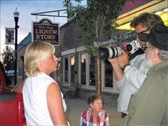

…Those who shared their encounters for the documentary film also underwent hypnosis and polygraph tests, Linda Cowen said. [3]
"The Secret of Redgate" won the People's Choice Award at the 2004 International UFO Congress conference in Nevada, selected from 15 films by more than 700 participants. [4]
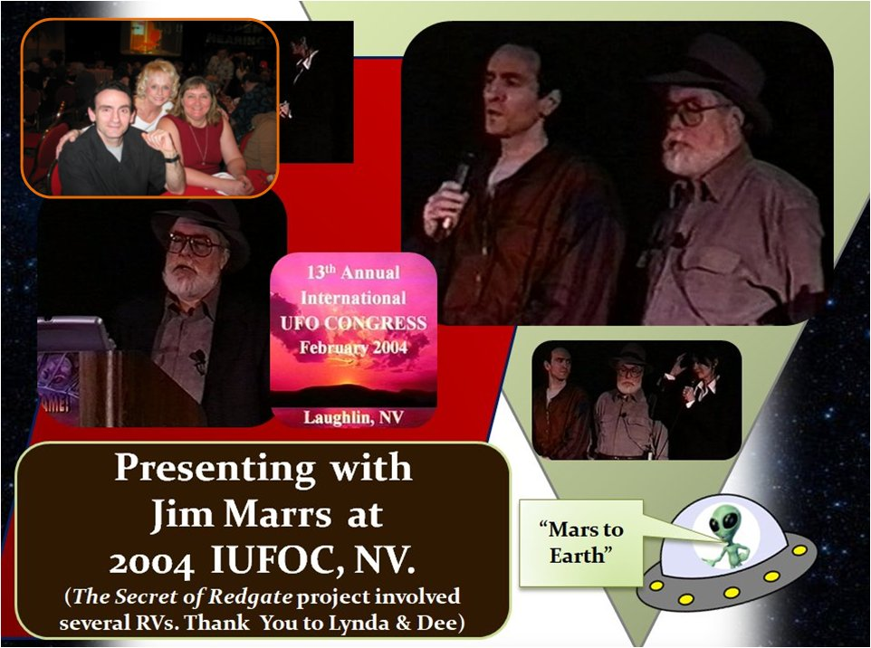

Source references:
- http://paranormalmontana.blogspot.com/2009/03/deer-lodge-and-red-gate.html

- https://helenair.com/news/film-claims-town-attracts-alien-visitors/article_b1850cd2-956b-5ff9-abb1-b7b727db4597.html

- ‘Ambassadors to the Stars’ - Sivalelli, Tony 2011 (rev 2015) Chapter 5.

- 2004 IUFOC presentation Laughlin, NV

